Telusko: Core Java 05

041 DOUBT
What are the topics for tomorrow's session?
Tommo topic: navin sir (SQL) for weekend batch enterprise java batch tommo at
9.00AMIST
JDBC(if time permits)
Sir cloneable small demo
Cloneable
=> it is a marker interface through which the objects can be cloned.
class Demo implements Cloneable
{
int i;
Demo(int i){
this.i =i;
}
}
Demo d1=new Demo(10);
Demo d2 =(Demo)d1.clone();
Q>
sir is interface which implemnets multiple inheritance?
interface IDemo{ void m1();}
interface ISample{void m2();}
class SampleImpl implements IDemo,ISample{
public void m1(){}
public void m2(){}
}
Q>
sir interface the word which works as srs and the interface which works as
implementation of multipleinheritance is that same?
Yes both are same..
Q>changes for mutable strings happen in existing object or a new object gets
created &
concept, need clarity
old reference points to a new object ? as you solved snippet with both
Integer x = 400;//wrapper class immutable
Integer y = x; // y = 400
x++; //x =401
System.out.println(x==y);//false
StringBuilder sb1 =new StringBuilder("sachin");//mutable
sb1.append("tendulkar");//sb1,sb2 = sachintendulkar
StringBuilder sb2 =sb1;
System.out.println(sb1==sb2);//true
Q>Why can't we override a static method sir?
static methods are dealing the information at class level,so overriding is
not possible rather
if we try to do it results in "Method hiding".
Q> interface A{}
class B implements A{}
A a=new B();Can we say refrence variable of A is the object of B?
ans. true
Q>sir y cant we create class as static but inner class as satic
Outermost class can't be marked as static becoz "static" refers to usage of
class without creating an Object.
where as inner class can be marked as static becoz "inner class" data can be
refered without creating the outer class Object.
Q> Sir this is one question interview question. What does null mean in java.
null in java represents a keyword where we can use it store the default
value for reference variables.
eg: String name = null; Date d =null;
Q> foremost advantage of HAS A realationship. we can aslo build without
realtionship aslo the output is same know sir?
HAS-A => communication and navigation of data is made simple
without HAS-A relationship the complexity of coding would increase.
Q> sir can you explain again why can't we override variables in interface?
overriding is not applicable for variables,it is applicable only for methods
Q> Can you give a brief about dependency injection?
The process of injecting dependent object into target object is called
"Dependancy injection".
It can be done in 2 ways
a. constructor
b. setter
eg: Flipkart(object)//target object
|
DTDC(object)// dependent object
Q> what is tight coupling and loose coupling
class Animal{}
class Monkey extends Animal{}
Monkey monkey = new Monkey();//tight coupling
Animal animal =Demo. getAnimal(); //loose coupling
class Demo{
public static Animal getAnimal(){
Animal animal =null
//logic of creating object
return animal;
}
}
Q> what is override toString methos do??
toString() -> it will be called automatically when we use object reference.
Normally in toString() we override to print the object data.
Q>
{
public enum Enum1 -> Enum1.class, Enum1$1.class, Enum1$2.class,Enum1$3.class
RED(100)
{
public void displaycolor(){
}
System.out.println("your color name is "+this);
},
GREEN(200)
{
{
}
public void displaycolor()
System.out.println("your color name is ");
},
BLUE(200)
{
{
}
public void displaycolor()
System.out.println("your color name is ");
};
{
}
private Enum1(int a)
System.out.println("I am in enum");
public abstract void displaycolor();
}
Ananomyous inner class
====================
final Parent p =new Child(){
}
abstract class A{}
abstract class B extends A{}
abstract class C extends B{}
class D extends C{}

042 Interface conclusion and Wrapper classes
When to go interface, abstract class and concrete class?
interface:: It is prefered when we speak only about specification(no
implementation).
abstract class:: It is prefered when we speak about partial implementation.
concreate class:: It is prefered when we speak about complete implementation and
ready to
provide service then we go for concrete class.
Difference b/w interface and abstract class?
Interface:: If we dont know anything about implementation just we have requirement
specification then we should
go for interface.
Abstract class: If we are talking about implementation but not completely then we
should go for abstract class.
Interface:: Every method present inside the interface is always public and
abstract whether we are declaring or
not.
Abstract :: Every method present inside abstract class need not be public and
abstract.
Interface:: We can't declare interface methods with the modifiers like
private,protected,final,static,synchronized,native,
strictfp.
Abstract :: There are not restrictions on abstract class method modifiers.
Interface:: Every interface variable is always public static final whether we are
declaring or not.
Abstract:: Every abstract class variable need not be public static final.
Interface:: Every interface variable is always public static final we can't
declare with the
following modifiers like
private,protected,transient,volatile.
Abstract:: No restriction on access modifiers
Interface:: For every interface variable compulsorily we should perform
initialisation at the time of declaration,
otherwise we get compile time error.
Abstract:: Not required to perform initialisation for abstract class variables
at the time of declaration.
Interface:: Inside interface we can't write static and instance block.
Abstract :: Inside abstract class we can write static and instance block.
Interface:: Inside interface we can't write constructor.
Abstract :: Inside abstract class we can write constructor.
Note:
static block => .class file loading happends and used to initialize
static variables.
instance block => during the creation of an object,just before the constructor call
used for initialization instance variable.
constructor => during the creation of an object, used for initialization
instance variable.
What is the need of abstract class? can we create an object of abstract class, Does
it contains constructor?
=> abstract class object cannot be created becoz it is abstract.=> But constructor is need for constructor to initialize the object.
eg::
class Parent {
Parent() {
System.out.println(this.hashCode());
}
}
class Child extends Parent {
public Child() {
System.out.println(this.hashCode());
}
}
public class TestApp {
public static void main(String[] args) {
Child c = new Child();
System.out.println(c.hashCode());
}
}
Why abstract class can contain constructor where as interface doesnot contain
constructor?
object.
abstract class =>constructor it is used to perform initialization of the
it is used to provide the value for the instance
variable.
it is used to contain instance variable which are
requried for child
object to perform intialisation for those
instance variables.
interface => every variable is always static,public and final their is no
chance of existing instance variable inside the class.
so we should perform initialisation at the time of
declaration.
so constructor is not required for interface.
eg#1.
abstract class Person{
String name;
int age;
int height;
int weight;
Person(String name,int age,int height,int weight){
super();
this.name=name;
this.age=age;
this.height=height;
this.weight weight;
}
}
class Student extends Person{
int rollno;
int marks;
Student(String name,int age,int height,int weight,int rollno,int marks){super(name,age,height,weight,rollno);
this.rollno=rollno;
this.marks=marks;
}
}
Question1:
Can reference be created for abstract class?
Person p =new Student("sachin",49,5.6f,71,10,100);
Can reference be created for interface?
ISample sample = null;
Note::Every method present inside the interface is abstract, but in abstract class
also we take only abstract methods then
what is the need of interface concept?
abstract class Sample{
public abstract void m1();
public abstract void m2();
}
interface ISample{
void m1();
void m2();
}
=> we can replace interface concept with abstract class, but it is not a good
programming practise.
eg#1
interface X{
...
...
}
class Test implements X{
...
...
}
Test t=new Test();
i. performance is high.
ii.While implementing X we can extends
one more class,through which we can bring reusablity.
eg#2.
abstract X{
...
...
}
class Test extends X{
...
...
}
Test t=new Test();
i.performance is low.
ii.While extending X we can't extends
any other classes so reusablity is not brought.Note: If everything is abstract then it is recommended to go for interface.
Wrapper class
============
Purpose
like objects.
1. To wrap primitives into object form so that we can handle primitives also just
2. To define several utility functions which are required for the primitives.
Constructors
===========
Almost all the Wrapper class have 2 constructors
a. one taking primitive type.
b. one taking String type.
eg: Integer i=new Integer(10);
Integer i=new Integer("10");
Double d=new Double(10.5);
Double d=new Double("10.5");
Note: If String argument is not properly defined then it would result in
RunTimeException called
"NumberformatException".
eg:: Integer i=new Integer("ten");//RE:NumberFormatException
Wrapper class and its associated constructor
Byte => byte and String
Short => short and String
Integer => int and String
Long => long and String
**Float => float ,String and double
Double => double and String
**Character=> character
***Boolean => boolean and String
eg::
1) Float f=new Float (10.5f);
2) Float f=new Float ("10.5f");
3) Float f=new Float(10.5);
4) Float f=new Float ("10.5");
eg::
1) Charcter c=new Character('a');
2) Character c=new Character("a"); //invalid
eg::
Boolean b=new Boolean(true);
Boolean b=new Boolean(false);
Boolean b1=new Boolean(True);//C.E
Boolean b=new Boolean(False);//C.E
Boolean b=new Boolean(TRUE);//C.E
eg::
Boolean b1=new Boolean("true");
Boolean b2=new Boolean("True");
Boolean b3=new Boolean("false");
Boolean b4=new Boolean("False");Boolean b5=new Boolean("nitin");
Boolean b6=new Boolean("TRUE");
System.out.println(b1);//true
System.out.println(b2);//true
System.out.println(b3);//false
System.out.println(b4);//false
System.out.println(b5);//false
System.out.println(b6);//true
eg::
class Test
{
{
public static void main(String[] args)
Boolean b1 =new Boolean("yes");//false
Boolean b2 =new Boolean("no");//false
System.out.println(b1);
System.out.println(b2);
System.out.println(b1.equals(b2));//false.equals(false)-> true
System.out.println(b1 == b2);//false
Integer i1 = new Integer(10);
Integer i2 = new Integer(10);
System.out.println(i1);//10
System.out.println(i2);//10
System.out.println(i1.equals(i2));//true
}
}
Note: In case of Boolean constructor, boolean value be treated as true w.r.t to
case insensitive
part of "true",for all others it would be treated as "false".
Note:
If we are passing String argument then case is not important and content is not
important.
If the content is case insensitive String of true then it is treated as true in
all other cases it is treated as false.
Note: In case of Wrapper class,toString() is overriden to print the data.
In case of Wrapper class,equals() is overriden to check the content.
Just like String class, Wrapper classes are also treated as "Immutable
class".
Immutable class
=============
If we create an Object and if we try to make a change, with that change new
object will be created and those changes
will not reflected in the old copy.
Can we make our userdefined class as Immutable?
ans. yes possible as shown below
final class Test{
}
int i;
Test(int i){
this.i = i;
}
public Test modify(int i){
if (this.i == i)
return this;
else
return new Test(i);
}
{
public static void main(String[] args)
Test t1 = new Test(10);
Test t2 = t1.modify(10);
Test t3 = t1.modify(100);
Test t4 = t3.modify(100);
System.out.println(t1==t2);//true
System.out.println(t1==t3);//false
System.out.println(t2==t3);//false
System.out.println(t3==t4);//true
}

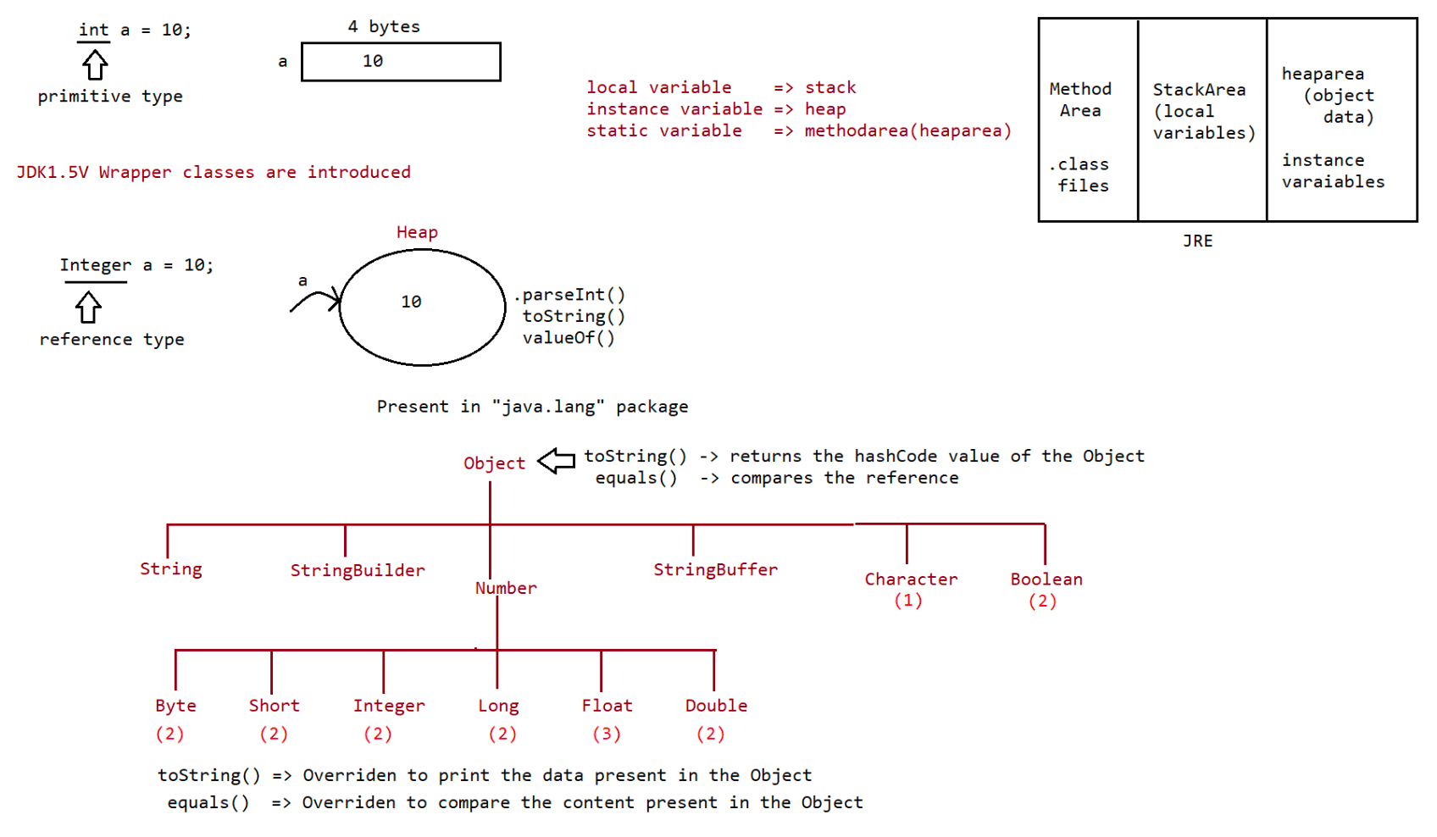
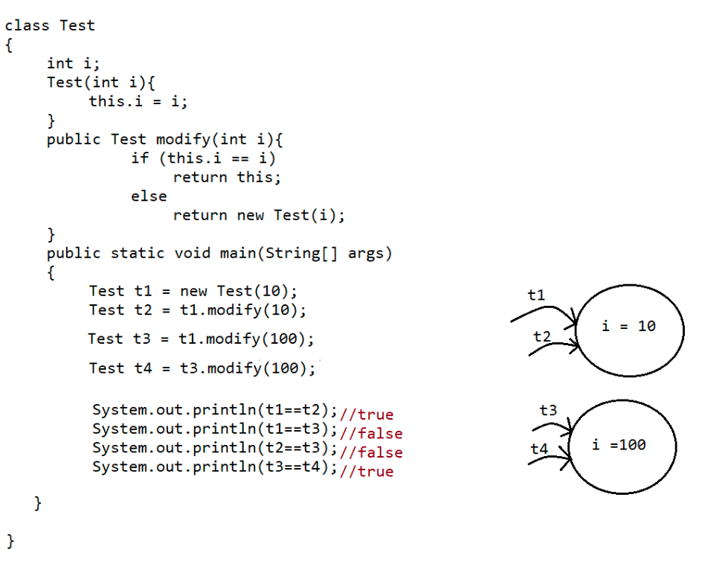

043 Wrapper class continuation
Wrapper class utiltiy methods
=============================
1. valueOf() method.
2. XXXValue() method.
3. parseXxx() method.
4. toString() method.
public static wrapper valueOf(String data, int radix) throws
java.lang.NumberFormatException;
public static wrapper valueOf(String data) throws
java.lang.NumberFormatException;
public static wrapper valueOf(int data);
valueOf() method
================
To create a wrapper object from primitive type or String we use valueOf().
It is alternative to constructor of Wrapper class, not suggestable to use.
Every Wrapper class,except character class contain static valueOf() to create a
Wrapper Object.
eg#1.
Integer i=Integer.valueOf("10");
Double d=Double.valueOf("10.5");
Boolean b=Boolean.valueOf("nitin");
System.out.println(i);
System.out.println(d);
System.out.println(b);
eg#2.
public static valueOf(String s,int radix)
|=> binary : 2(0,1)
|=> octal : 8(0-7)
|=> decimal : 10(0-9)
|=> hexadecimal : 16(0-9,a,b,c,d,e,f)
|=> base : 36(0-9,a-z)
Integer i1=Integer.valueOf("1111");
System.out.println(i1);//1111
Integer i2=Integer.valueOf("1111",2);
System.out.println(i2);//15
Integer i3=Integer.valueOf("ten");
System.out.println(i3);//RE:NumberFormatException
Integer i4=Integer.valueOf("1111",37);
System.out.println(i4);//RE:NumberFormatException
eg#3.
public static valueOf(primitivetype x)
Integer i1=Integer.valueOf(10);
Double d1=Double.valueOf(10.5);
Character c=Character.valueOf('a');
Boolean b=Boolean.valueOf(true);
Primtive/String =>valueOf() => WrapperObject
2. xxxValue()
We can use xxxValue() to get primitive type for the given Wrapper Object.
These methods are a part of every Number type Object.
(Byte,Short,Integer,Long,Float,Double) all these classes have these 6 methods
which isWritten as shown below.
Methods
=======
public byte byteValue();
public short shortValue();
public int intValue();
public long longValue();
public float floatValue();
public double doubleValue();
eg#1.
Integer i=new Integer(130);
// result = minrange +(total -maxrange -1)
System.out.println(i.byteValue());//-126
System.out.println(i.shortValue());//130
System.out.println(i.intValue());//130
System.out.println(i.longValue());//130
System.out.println(i.floatValue());//130.0
System.out.println(i.doubleValue());//130.0
3. charValue()
Character
Character class contains charValue() to get Char primitive for the given
Object.
public char charValue()
eg#1.
Character c=new Character('c');
char ch= c.charValue();
System.out.println(ch);
4. booleanValue()
given boolean
Boolean class contains booleanValue() to get boolean primitive for the
Object.
public boolean booleanValue()
eg#1.
Boolean b=new Boolean("nitin");
boolean b1=b.booleanValue();
System.out.println(b1);//false
In total xxxValue() are 36 in number.
=> xxxValue() => convert the Wrapper Object => primitive.
parseXXXX()
===========
We use parseXXXX() to convert String object into primitive type.
form-1
======
public static primitive parseXXX(String s)
Every wrapper class,except Character class has parseXXX() to convert String into
primitive type.
eg: int i=Integer.parseInt("10");
double d =Double.parseInt("10.5");
boolean b=Boolean.parseBoolean("true");usage of Wrapper class in realtime coding
==================================
//WAP to take inputs from the command line and perform arithemetic operations
class Test
{
public static void main(String[] args)
{
//valueOf() => Converts String/Primitive to Wrapper type
//xxxValue() => Converts Wrapper type to Primitive type
//parseXXX() => converts String to primitive type
//commandline arguments => String inputs = args[0],args[1]
int i1 = Integer.parseInt(args[0]);
int i2 = Integer.parseInt(args[1]);
System.out.println(i1+i2);
System.out.println(i1-i2);
System.out.println(i1*i2);
System.out.println(i1/i2);
//args -> String, convert into primitive type and process
}
}
form-2
======
public static primitive parseXXXX(String s, int radix)
|=> range is from 2 to 36
Every Integral type Wrapper class(Byte,Short,Integer,Long) contains the following
parseXXXX()
to convert Specified radix String to primitive type.
eg: int i=Integer.parseInt("1111",2);
System.out.println(i);//15
Note: String => parseXXX() => primitive type
toString()
=========
To convert the Wrapper Object or primitive to String.
Every Wrapper class contain toString()
form1
=====
public String toString()
1. Every wrapper class (including Character class) contains the above toString()
method to convert wrapper object to String.
2. It is the overriding version of Object class toString() method.
3. Whenever we are trying to print wrapper object reference internally this
toString() method only executed
eg: Integer i=Integer.valueOf("10");
System.out.println(i);//internally it calls toString() and prints the Data.form2
=====
public static String toString(primitivetype)
1. Every wrapper class contains a static toString() method to convert primitive to
String.
String s=Integer.toString(10);
|=> primitive type int.
eg:
String s=Integer.toString(10);
String s=Boolean.toString(true);
String s=Character.toString('a');
form3
=====
the
Integer and Long classes contains the following static toString() method to convert
primitive to specified radix String form.
public static String toString(primitive p,int radix)
|=> 2 to 36
eg: String s=Integer.toString(15,2)
System.out.println(s); // 1111
form4
=====
Integer and Long classes contains the following toXxxString() methods.
public static String toBinaryString(primitive p);
public static String toOctalString(primitive p);
public static String toHexString(primitive p);
Example:
class WrapperClassDemo {
public static void main(String[] args) {
String s1=Integer.toBinaryString(7);
String s2=Integer.toOctalString(10);
String s3=Integer.toHexString(20);
String s4=Integer.toHexString(10);
System.out.println(s1);//111
System.out.println(s2);//12
System.out.println(s3);//14
System.out.println(s4);//a
}
}
Note:
String class
public static String valueOf(boolean);
public static String valueOf(char);
public static String valueOf(int);
public static String valueOf(long);
public static String valueOf(float);
public static String valueOf(double);String data = String.valueOf('a');//static factory methods
String data = "sachin".toUpperCase();//instance factory methods
AutoBoxing and AutoUnBoxing
=========================
untill 1.4Version, we can't provide wrapper class objects in place of primitive and
primitive in place of wrapper object all
the required conversions should be done by the programmer.
But from jdk1.5 Version onwards,we can provide primtive in place of wrapper and in
place of wrapper we can keep primitive
also.All the requried conversion will be done by the compiler automatically, this
mechanism is called as "AutoBoxing" and
"AutoUnBoxing".
eg#1.
if (b1)
Boolean b1 = Boolean.valueOf(true);
System.out.println("hello");
eg#2.
ArrayList al = new ArrayList();
al.add(10);
Autoboxing
=========
"AutoBoxing".
Integer i1 = 10;
Automatic conversion of primtive type to wrapper object by the compiler is called
|
|After compilation the code would be
|
|
Integer i1 = Integer.valueOf(10);
Note: Autoboxing is done by the compiler using a method called "valueOf()".
AutoUnBoxing
============
"AutoUnBoxing".
Automatic conversion of wrapper object to primtive type by compiler is called
Integer i1 = new Integer(10);
int i2 = i1;
|
|
|compiler converts Integer to int type using intValue()
int i2 = i1.intValue();
Note: AutoUnboxing is done by the compiler using a method called "xxxValue()"
Case1:
=====
class Test
{
static Integer i1 = 10;// AutoBoxing
public static void main(String[] args){
int i2 = i1;//AutoUnBoxing
m1(i2);
}
public static void m1(Integer i2){//AutoBoxing
int k = i2;//AutoUnBoxing
System.out.println(k);//10
}
}
Compiler is responsible for conversion of primitive to wrapper and wrapper to
primitive using the concept of
"AutoBoxing and AutoUnBoxing".
case2:
class Test
{
static Integer i1;//i1 = null
public static void main(String[] args)
{
int i2 = i1;// int i2 = i1.intValue() :: NullPointerException
System.out.println(i2);
}
}
Case3 :
Integer i1 = 10;//AutoBoxing
Integer i2 = i1;
i1++; = > i1 = i1+1
System.out.println(i1);
System.out.println(i2);
System.out.println(i1==i2);
Case4:
Integer x = new Integer(10);
Integer y = new Integer(10);
System.out.println(x == y);//false
Case5:
Integer x = new Integer(10);//memory from heap area
Integer y = 10;//AutoBoxing ===> Integer y = Integer.valueOf(10);
System.out.println(x == y);//false
Case6:
Integer x = new Integer(10);
Integer y = x; ===> reference is reused so pointing to same object
System.out.println(x == y);//true
Case7:
Integer x = 10;
Integer y = 10;
System.out.println(x == y);
Integer a = 100;
Integer b = 100;
System.out.println(a == b);
Integer i = 1000;
Integer j = 1000;System.out.println(i == j);
Note:
1. To implement autoboxing concpet in wrapper class a buffer of object will be
created at the time of class loading.
2. During AutoBoxing,if an object has to be created first jvm will check whether
the object is already available inside buffer
or not.
3. If it is available, then JVM will reuse the buffered object instead of creating
a new Object.
4. If the Object is not available inside buffer, then jvm will create a new object
in the heap area, this approach improves the
performance and memory utilization
But this buffer concept is applicable only for few cases
1. Byte => -128 to +127
2. Short => -128 to +127
3. Integer=> -128 to +127
4. Long => -128 to +127
5. Character => 0 to 127
6. Boolean => true,false
In the remaining cases new object will be created.
// String/primtive to wrapper => valueOf()
// Wrapper type to primitive => xxxValue()
class Test
{
public static void main(String[] args)
{
Integer x = 128;
Integer y = 128;
System.out.println(x == y);//false
Integer a = 127;
Integer b = 127;
System.out.println(a == b);//true
Boolean b1 = true;
Boolean b2 = true;
System.out.println(b1==b2);//true
Double d1 = 10.0;
Double d2 = 10.0;
System.out.println(d1==d2);//false
}
}

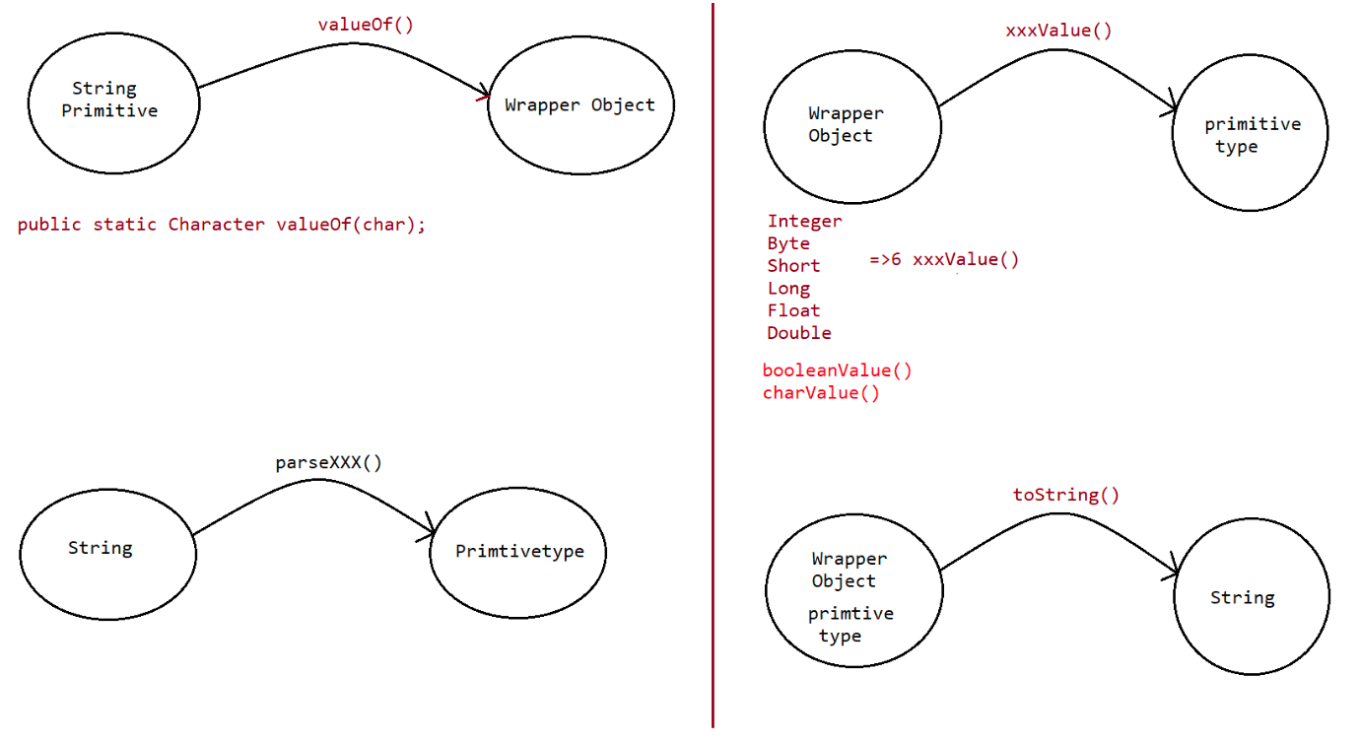
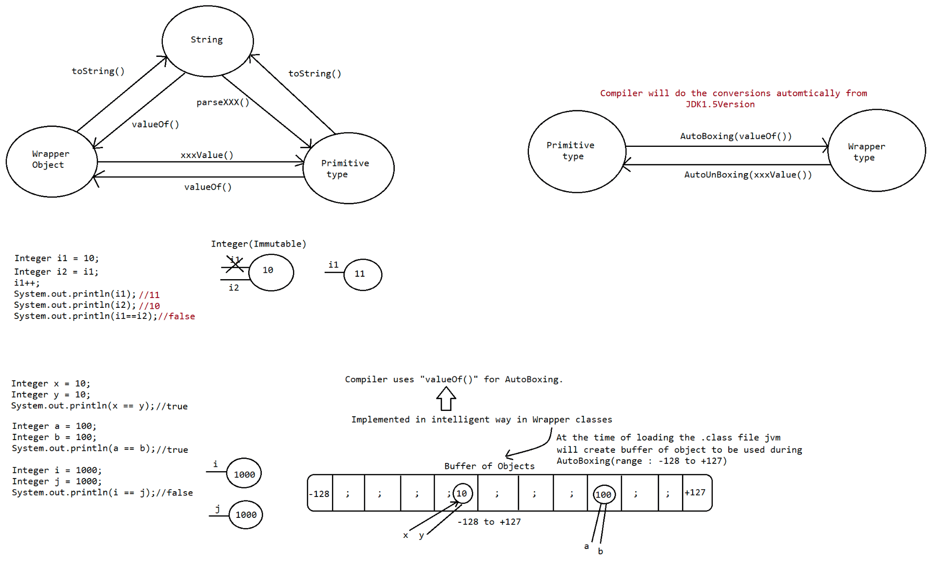

044 varargs and new vs newInstance()
Snippets
=======
Integer i1= new Integer(10);
Integer i2= new Integer(10);
System.out.println(i1==i2);//false
Integer i1 = 10;
Integer i2 = 10;
System.out.println(i1==i2);//true
Integer i1 =Integer.valueOf(10);
Integer i2 =Integer.valueOf(10);
System.out.println(i1==i2);//true
Integer i1 =10;
Integer i2 =Integer.valueOf(10);
System.out.println(i1==i2);//true
Note:
When compared with constructors it is recommended to use valueOf() method to create
wrapper object.
Var arg method
==============
It stands for variable argument methods.
In java language,if we have variable no of arguments, then compulsorily new
method has to be written till jdk1.4.
But jdk1.5 version, we can write single method which can handle variable no of
arguments(but all of them should be of same type).
Syntax:: methodOne(dataType... varaibleName)
... => It stands for ellipse
eg#1.
class Demo
{
}
}
class Test
{
{
//JDK1.5V called Var-args(ellipse)
public void add(int... x){
System.out.println("var-arg approach");
public static void main(String[] args)
Demo d =new Demo();
d.add();
d.add(10);
d.add(10,20);
d.add(10,20,30);
}
}
Output
var-arg approach
var-arg approach
var-arg approach
var-arg approach
can access the
Note:: internally the var arg method will converted to SingleDimension Array, so wevar arg method arguments using index.
eg2::
{
class Demo
public void methodOne(int... x){
int total=0;
for(int i=0;i<x.length;i++){
total+=x[i];
}
}
System.out.println("The sum is "+total);
public static void main(String[] args){
Demo d= new Demo();
d.methodOne();//The sum is 0
d.methodOne(10);//The sum is 10
d.methodOne(10,20,30);// The sum is 60
}
}
eg3::
{
class Demo
public void methodOne(int... x){
int total =0;
for(int data:x){total+=data;}
System.out.println("The sum is "+total);
}
public static void main(String[] args){
Demo d= new Demo();
d.methodOne();//The sum is 0
d.methodOne(10);//The sum is 10
d.methodOne(10,20,30);// The sum is 60
}
}
case1
=====
Valid Signatures
1.public void methodOne(int... x)
2.public void methodOne(int...x)
3.public void methodOne(int ...x)
case2
=====
We can mix normal argument with var argument
public void methodOne(int x,int... y)
public void methodOne(String s,int... x)
case3
=====
While mixing var arg with normal argument var arg should be always last.
public void methodOne(int... x,int y); (invalid)
case4
=====
In an argument list there should be only one var argument
public void methodOne(int... x,int ...y); (invalid)case5
=====
We can overload var arg method, but var arg method will get a call only if none of
matches are found.
(just like default statement of switch case)
eg::
{
class Test
public void methodOne(int ...i){System.out.println("Var arg method");}
public void methodOne(int i){System.out.println("Int arg method");}
public static void main(String[] args)
{
Test t= new Test();
t.methodOne(10);//Int arg method
t.methodOne();//Var arg method
t.methodOne(10,20,30);//Int arg method
}
}
case6
=====
public void methodOne(int... x) => it can be replace as int[] x
case7
=====
public void methodOne(int... x)
public void methodOne(int[] x)
output:: CE because we cannot have two methods with same signature.
SingleDimension Array vs Var Arg method
=======================================
1. Whereever Singledimesion array is present we can replace it with Var Arg.
eg:: public static void main(String[] args) => String... args
2. Whereever Var arg is present we cannot replace it with SingleDimension
Array.
eg:: public void methodOne(String... args) => String[] args (invalid)
Note:
m1(int... x)
become 1D array(int[] x)
=> we can call to this method by passing group of int values and x will
m1(int[] x)
=> we can call to this method by passing 1D array only.
Note::
eg1::
class Test
{
public void methodOne(int... x){
for(int data: x){
System.out.println(data);
}}
public static void main(String... args){
Test t= new Test();
t.methodOne(10,20,30);
}
}
eg2::
class Test
{
In the above pgm x is treated as One-D array.
public void methodOne(int[]... x){
for(int[] OneD: x){
for(int element:oneD){
System.out.println(data);
}
}
}
public static void main(String... args){
Test t= new Test();
int[] a= {10,20,30};
int[] b= {30,40};
t.methodOne(a,b);
}
}
In the above program x is treated as 2D array
Note::
methodOne(int...x)
becomes 1-D array.
methodOne(int[]... x)
becomes 2-D array.
=> we can call this method by passing a group of int values,so it
=> we can call this method by passing a group of 1D int[], so it
Wrapper class
============
1. AutoBoxing
2. Widening(Implicit TypeCasting done by the Compiler (applicable for both
primitive and Wrapper type))
3. Var-Args
case1::
Widening vs Autoboxing
class AutoBoxingAndUnboxingDemo {
public static void methodOne(long l) {
System.out.println("widening");
}
public static void methodOne(Integer i) {
System.out.println("autoboxing");
}
public static void main(String[] args) {
int x=10;
long(binding happens by compiler)
methodOne(x); // primtive ====> do type casting====> found ==>}
}
output: widening
case2::Widening vs var-arg method
class AutoBoxingAndUnboxingDemo {
public static void methodOne(long l) {
System.out.println("widening");
}
public static void methodOne(int... i) {
System.out.println("var-arg method");
}
public static void main(String[] args) {
int x=10;
methodOne(x); // primtive ====> do type casting====>
found ==> long(binding happens by compiler)
}
}
output: widening
Case 3: Autoboxing vs var-arg method :
class AutoBoxingAndUnboxingDemo {
public static void methodOne(Integer i) {
System.out.println("AutoBoxing");
}
public static void methodOne(int... i) {
System.out.println("var-arg method");
}
public static void main(String[] args) {
int x=10;
methodOne(x); // int =====> implicit type casting===>
long,float,double
// int =====> Autoboxing ===> Integer
}
}
Output: AutoBoxing
Case4:
class AutoBoxingAndUnboxingDemo {
public static void methodOne(Long l) {
System.out.println("Long");
}
public static void main(String[] args) {
int x=10;
methodOne(x); //CE: can't find the method
}
}
Note:
Widening followed by Autoboxing is not allowed in java, but Autoboxing followed by
widening is allowed.
Case 5:
class AutoBoxingAndUnboxingDemo {
public static void methodOne(Object o) {
System.out.println("Object");
}
public static void main(String[] args) {int x=10;
methodOne(x); // AutoBoxing ===> int ===> Integer
// Widening ===> Integer ====>
Number,Object
}
}
Output: Object
Which of the following declarations are valid ?
1. int i=10 ;//valid
2. Integer I=10 ; //AutoBoxing(valueof())
3. int i=10L ; // invalid(long===> int)
4. Long l = 10L ; //AutoBoxing(valueOf())
5. Long l = 10 ; //AutoBoxing=> Integer====> Number,Object , so invalid
6. long l = 10 ; // valid(int===> long)
7. Object o=10 ; //AutoBoxing==> Integer ===> Number,Object so valid
8. double d=10 ; // valid(int===> double)
9. Double d=10 ; // AutoBoxing=> Integer====> Number,Object , so invalid
10. Number n=10; //AutoBoxing==> Integer ===> Number,Object so valid
new Vs newInstance( )
==================
1. new is an operator to create an objects , if we know class name at the beginning
then we can create an object by using
new operator .
2. newInstance( ) is a method presenting class " Class " , which can be used to
create object.
3. If we don't know the class name at the beginning and its available dynamically
Runtime then we should go for
newInstance() method
eg#1.
public class Test {
public static void main(String[] args) throws Exception {
//Take the input of the classname for which object has to be created at
the runtime
String className = args[0];
//Load the class file explicitly
Class c = Class.forName(className);
//for the loaded class object is created using zero param constructor
only
Object obj=c.newInstance();
//Perform type casting to get Student Object
Student std = (Student)obj;
System.out.println(std);
}
}
If dynamically provide class name is not available then we will get the
RuntimeException saying ClassNotFoundException
To use newInstance( ) method compulsory corresponding class should contains no
argument constructor ,
otherwise we will get the RuntimeException saying "InstantiationException".if the argument constructor is private then it would result in
"IllegalAccessException".
Note: During typecasting, if there is no relationship b/w 2 classes as parent to
child then it would result in "ClassCastException".
Difference between new and newInstance( ) :
new
===
new is an operator , which can be used to create an object.
We can use new operator if we know the class name at the beginning.
Test t= new Test( );
If the corresponding .class file not available at Runtime then we will get
RuntimeException saying NoClassDefFoundError,It is unchecked.
To used new operator the corresponding class not required to contain no argument
constructor.
newInstance( )
============
newInstance( ) is a method , present in class Class , which can be used to create
an object .
We can use the newInstance( ) method , If we don't class name at the beginning and
available dynamically Runtime.
Object o=Class.forName(arg[0]).newInstance( );
If the corresponding .class file not available at Runtime then we will get
RuntimeException saying ClassNotFoundException , It is checked.
To used newInstance( ) method the corresponding class should compulsory contain no
argument constructor , Other wise we will get
RuntimeException saying InstantiationException.
Difference between ClassNotFoundException & NoClassDefFoundError :
1. For hard coded class names at Runtime in the corresponding .class files not
available we will get NoClassDefFoundError ,
which is unchecked
Test t = new Test( );
In Runtime Test.class file is not available then we will get
NoClassDefFoundError
2. For Dynamically provided class names at Runtime , If the corresponding .class
files is not available then we will get the
RuntimeException saying "ClassNotFoundException".
Ex : Object o=Class.forname("Test").newInstance( );
At Runtime if Test.class file not available then we will get the
ClassNotFoundException , which is checked exception.
Note:
new will create a memory on the heap area
Student => JVM will search for Student.class file in Current Working Directory
if found load the .class file data into MethodArea
During the loading of .class file
a. static variables will get memory set with default vaalue
b. static block gets executedIn the heap area, for the required object memory for instance variables is given
jvm will set the default values to it
a. Execute the instance block if available
b. call the constructor to set the meaningful values to the instance
varaibles.
JVM will give the address of the object to hashing algorithm which generates the
hashCode for the object and that hashCode
will be returned as the reference to the programmer
new => requried class details known to compiler but not available at jvm then it
would result in "NoClassDefFoundError"
newInstance() => requried class details not available at jvm then it would result
in "ClassNotFoundException"
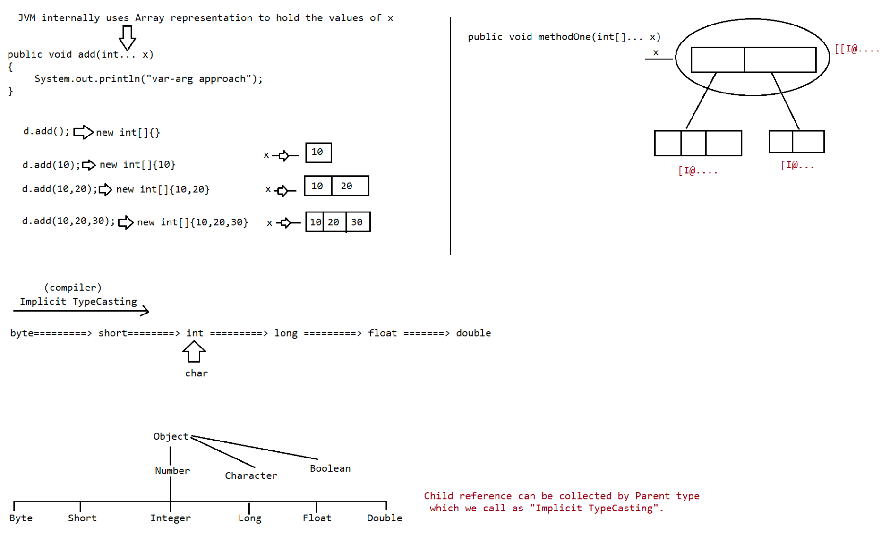

045 DOUBT
contact details:
hyder: syedhyder@ineuron.ai
nitin : nitin@ineuron.ai
Todays topic for Java Full Stack(7.30PM IST batch)
a. Wrapper classes continuation
b. var-args
c. Different ways of creating an Object
d. Difference b/w ClassNotFoundException vs NoClassDefFoundError
e. instanceof vs isInstance()
f. packages and import statements usage
Q>
public static <T> void sort(java.util.List<T>, java.util.Comparator<? super T>);
ArrayList<Integer> al = new ArrayList<Integer>();
al.add(10);
al.add(20);
al.add(5);
al.add(0);
Collections.sort(al) ==sort====> <Integer>
Q> sir if we create interface serializable and interface of cloneable you gave
example i did'nt understand i also rewatched the video
class Sample implements Serializable,Cloneable{
}
interface.
new SampleImpl(); =>Object can be cloned using clone() becoz of Cloneable
Object can be sent over the network store the state
of the Object in a file becoz class implements Serializable.
Q>
Byte b1 = new Byte((byte) 22);
Byte b2 = new Byte((byte) -128);
Byte b3 = new Byte((byte) +127);
Byte b4 = new Byte((byte) 'a');//97
Byte b5 = new Byte("20");
Byte b6 = new Byte((byte) '7');
System.out.println(b1);//22
System.out.println(b2);//-128
System.out.println(b3);//127
System.out.println(b4);//97
System.out.println(b5);//20
System.out.println(b6);//55
System.out.println();
sir proper defination of class , object and interface ??
: It is template or blue print for which an Instance should be
class created.
Object Interface 100%abstract class.
: It is an instance of a class
: It refers to SRS or contract b/w client and service provider or

046 Import statements, Functional interface, Lambda expression
Import statement
==============
class Test{
public static void main(String args[]){
ArrayList l=new ArrayList();
}
}
Output:
Compile time error.
D:\Java>javac Test.java
Test.java:3: cannot find symbol
symbol : class ArrayList
location: class Test
ArrayList l=new ArrayList();
=> We can resolve this problem by using fully qualified name "java.util.ArrayList"
l=new java.util.ArrayList();". But problem with using fully qualified name
every time is it increases length of the code and
reduces readability.
=> We can resolve this problem by using import statements.
Example:
import java.util.ArrayList;
class Test{
public static void main(String args[]){
ArrayList l=new ArrayList();
}
}
Output:
D:\Java>javac Test.java
Hence whenever we are using import statement it is not require to use fully
qualified names we can use short names directly.
This approach decreases length of the code and improves readability.
Case 1: Types of Import Statements:
There are 2 types of import statements.
1) Explicit class import
2) Implicit class import.
Explicit class import:
Example: Import java.util.ArrayList ;
=> This type of import is highly recommended to use because it improves
readability of the code.
=> Best suitable for developers where readability is important.
Implicit class import:
Example: import java.util.*;
=> It is never recommended to use because it reduces readability of the code.
=> Best suitable for students where typing is important.
Case 2:
Which of the following import statements are meaningful ?
a. import java.util;
b. import java.util.ArrayList.*;
c. import java.util.*;
d. import java.util.ArrayList;Answer: c and d
Case3:
consider the following code.
class MyArrayList extends java.util.ArrayList
{
}
=> The code compiles fine even though we are not using import statements because we
used fully qualified name.
=> Whenever we are using fully qualified name it is not required to use import
statement.
Similarly whenever we are using import statements it is not require to use
fully qualified name.
Case4:
import java.util.*;
import java.sql.*;
class Test{
public static void main(String args[]) {
Date d=new Date();
}
}
Output:
Compile time error.
D:\Java>javac Test.java
Test.java:7: reference to Date is ambiguous,
both class java.sql.Date in java.sql and class java.util.Date in java.util match
Date d=new Date();
Note: Even in the List case also we may get the same ambiguity problem because it
is available in both util and awt packages.
Case5:
While resolving class names compiler will always gives the importance in the
following order.
1. Explicit class import
2. Classes present in current working directory.
3. Implicit class import.
Example:
import java.util.Date;
import java.sql.*;
class Test {
public static void main(String args[]){
Date d=new Date();
}
}
The code compiles fine and in this case util package Date will be considered.
Case 6:
Whenever we are importing a package all classes and interfaces present in that
package are by default available but not
sub package classes.
java
|=> util
|=> Scanner.class,ArrayList.class,LinkedList.class|=> regex
|=> Pattern.class
To use Pattern class in our Program directly which import statement is required ?
a. import java.*;
b. import java.util.*;
c. import java.util.regex.*; //valid(implicit import)
d. import java.util.regex.Pattern;//valid(explicit import)
Note:
* => it refers to only .class files not subpackages .class files
Case7:
In any java Program the following 2 packages are not require to import because
these are available by default to every java Program.
1. java.lang package
2. default package(current working directory)
Case 8:
"Import statement is totally compile time concept" if more no of imports are there
then more will be the compile time
but there is "no change in execution time".
Difference between C language #include and java language import ?
#include
=======
1. It can be used in C & C++
2. At compile time only compiler copy the code from standard library and placed in
current program.
3. It is static inclusion
4. wastage of memory
Ex : <jsp:@ file="">
import
======
1. It can be used in Java
2. At runtime JVM will execute the corresponding standard library and use it's
result in current program.
3. It is dynamic inclusion
4. No wastage of memory
Ex : <jsp:include >
Note:
In the case of C language #include all the header files will be loaded at the time
of include statement hence it follows static loading.
But in java import statement no ".class" will be loaded at the time of import
statements in the next lines of the code whenever we are
using a particular class then only corresponding ".class" file will be loaded.
Hence it follows "dynamic loading" or
"load-on -demand" or "load-on-fly".
JDK 1.5 versions new features :
1. For-Each
2. Var-arg3. Queue
4. Generics
5. Auto boxing and Auto unboxing
6. Co-varient return types
7. Annotations
8. Enum
9. Static import
10. String builder
Static import:
This concept introduced in 1.5 versions. According to sun static import improves
readability of the code but according to
worldwide Programming exports (like us) static imports creates confusion and
reduces readability of the code. Hence if there is no
specific requirement never recommended to use a static import.
Usually we can access static members by using class name but whenever we are using
static import it is not require to use class name
we can access directly.
Without static import:
class Test
{
public static void main(String args[]){
System.out.println(Math.sqrt(4));
System.out.println(Math.max(10,20));
System.out.println(Math.random());
}
}
Output:
D:\Java>javac Test.java
D:\Java>java Test
2.0
20
0.841306154315576
With static import:
import static java.lang.Math.sqrt;
import static java.lang.Math.*;
class Test{
public static void main(String args[]){
System.out.println(sqrt(4));
System.out.println(max(10,20));
System.out.println(random());
}
}
Output:
D:\Java>javac Test.java
D:\Java>java Test
2.0
20
0.4302853847363891
class Test{
static String name = "sachin";
}
output======
Test.name.length() ====> 6
import java.io.PrintStream;
class System{
static PrintStream out;
}
class PrintStream{
public void println(){
;;;;;;
}
}
System.out.println()
| | |=> It is a method of PrintStream class
| |
| |=> It is a reference of PrintStream Class
|=> it is an class
Example 3:
import static java.lang.System.out;
class Test{
public static void main(String args[]){
out.println("hello");
out.println("hi");
}
}
Output:
D:\Java>javac Test.java
D:\Java>java Test
hello
hi
Example 4:
import static java.lang.Integer.*;
import static java.lang.Byte.*;
class Test{
public static void main(String args[]){
System.out.println(MAX_VALUE);
}
}
Output:
Compile time error.
D:\Java>javac Test.java
Test.java:6: reference to MAX_VALUE is ambiguous,
both variable MAX_VALUE in java.lang.Integer and variable MAX_VALUE in
java.lang.Byte match
System.out.println(MAX_VALUE);
Note:
Two packages contain a class or interface with the same is very rare hence
ambiguity problem is very rare in normal import.
But 2 classes or interfaces can contain a method or variable with the same name is
very common hence ambiguity
problem is also very common in static import.
While resolving static members compiler will give the precedence in the followingorder.
1. Current class static member
2. Explicit static import
3. implict static import
eg:
import static java.lang.Integer.MAX_VALUE;
import static java.lang.Byte.*;
class Test{
static int MAX_VALUE = 999;
public static void main(String[] args){
System.out.println(MAX_VALUE);
}
}
Which of the following import statement is valid?
import java.lang.Math.*; //invalid
import static java.lang.Math.*;//valid
import java.lang.Math;//valid
import static java.lang.Math;//invalid
import static java.lang.Math.sqrt.*;//invalid
import java.lang.Math.sqrt;//invalid
import static java.lang.Math.sqrt();//invalid
import static java.lang.Math.sqrt;//valid
Usage of static import reduces readability and creates confusion hence if there is
no specific requirement never recommended to use
static import.
What is the difference between general import and static import ?
normal import
============
=> We can use normal imports to import classes and interfaces of a package.
=> whenever we are using normal import we can access class and interfaces directly
by their short name it is not
require to use fully qualified names.
static import
===========
=> We can use static import to import static members of a particular class.
=> whenever we are using static import it is not require to use class name we can
access static members directly.

//@FunctionalInterface
interface Demo
{
void disp();
void add(int a, int b);
}
/*
* class Trial implements Demo { public void disp() {
* System.out.println("Hello Java Lovers"); } }
*/

public class Launch1 {

public static void main(String[] args)
{

Demo demo=new Demo() {

public void disp()
{
System.out.println("Hello");
}
public void add(int a, int b)
{
int c=a+b;
System.out.println(c);
}
};
demo.disp();
demo.add(10, 20);
/*
* Trial t=new Trial(); t.disp();
*/
// Demo d= ()->System.out.println("Hello iNeuron learners");
// d.disp();

}
}

//
@FunctionalInterface
interface Add
{
void add(int a, int b);
}
@FunctionalInterface
interface Sub
{
int sub(int num1);
}

// to write lambda exp we use lambda operator (->)
// lambda operator divided into 2 parts to writw lambda exp
// left side of lambda operator we write parameters required
//right side of lambda operator we write body or implementation
// left side for parameters datatype is optional
// write side if implementation or body has one statement then {} is optional
// left side if parameter is single then () and type of data both optional
// write side in body if its single line implementaion then return statement is also optional
// {} is mandtaory if there are more then one statement and also if there is return statement explictly used by developer
public class LaunchLambda {

public static void main(String[] args)
{
Add add= (a, b)->{
int res=a+b;
System.out.println(res);
};

add.add(10, 20);

// Sub sub= num1->{
// int res=num1-5;
// return res;
// };
// Sub sub= num1 -> {
// return num1-5;
// };
Sub sub= num1 -> num1-5;

}

}
// WAP to compute length of String
@FunctionalInterface
interface CLS
{
int getLength(String str);
}

//#1
//class LOS implements CLS
//{
// public int getLength(String str)
// {
// int length=str.length();
// return length;
// }
//}

public class LaunchLambda2 {

public static void main(String[] args)
{
// LOS l=new LOS();
// System.out.println(l.getLength("iNeuron.ai"));

// CLS cls=new CLS() {
//
// public int getLength(String str)
// {
// return str.length();
// }
// };
// System.out.println(cls.getLength("iNeuron.ai"));

CLS cls= str -> str.length();

System.out.println(cls.getLength("iNeuron.ai"));

}

}

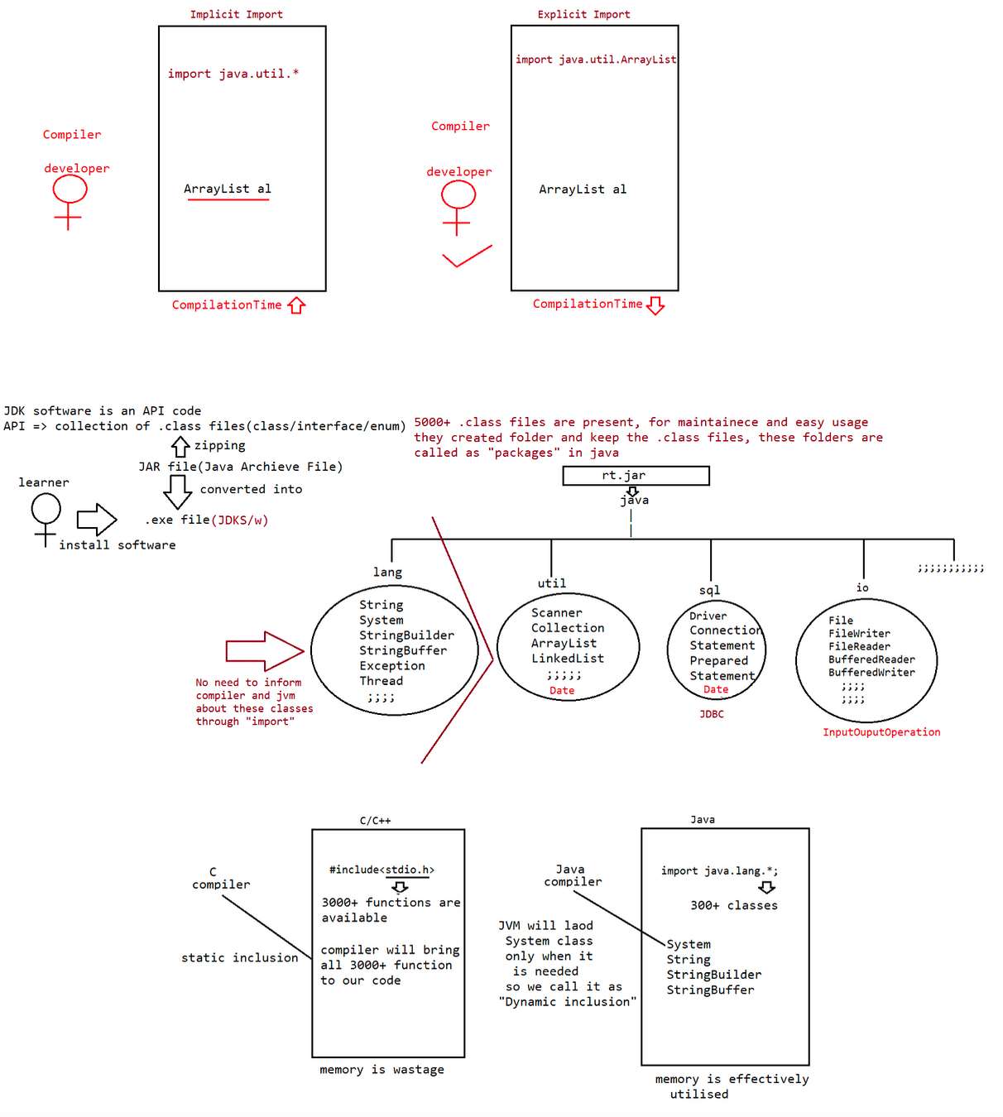

047 Exception Handling
Given:
1. public class Barn {
2. public static void main(String[] args) {
3. new Barn().go("hi", 1);
4. new Barn().go("hi", "world", 2);
5. }
6. 7. public void go(String... y, int x) {
System.out.print(y[y.length - 1] + " ");
8. }
9. }
What is the result?
A. hi hi
B. hi world
C. world world
D. Compilation fails.
E. An exception is thrown at runtime.
Answer: D
Q>
What is the result?
11. public class Person {
12. String name = "No name";
13. public Person(String nm) { name = nm; }
14. }
15.
16. public class Employee extends Person {
17. String empID = "0000";
18. public Employee(String id) { empID = id; }
19. }
20.
21. public class EmployeeTest {
22. public static void main(String[] args){
23. Employee e = new Employee("4321");
24. System.out.println(e.empID);
25. }
26. }
Choose the answer
A. 4321
B. 0000
C. An exception is thrown at runtime.
D. Compilation fails because of an error in line 18.
Question
1. public class Mud {
2. //insert code here
3. System.out.println("hi");
4. }
5. }
And the following five fragments:
public static void main(String...a) {
public static void main(String.* a) {
public static void main(String... a) {
public static void main(String[]... a) {
public static void main(String...[] a) {
How many of the code fragments, inserted independently at line 2, compile?
A. 0B. 1
C. 2
D. 3
E. 4
F. 5
Answer: D
QUESTION
Given:
1. class Atom {
2. Atom() {super(); System.out.print("atom "); }
3. }
4. class Rock extends Atom {
Rock(String type) { super(); System.out.print(type); }
5. 6. }
7. public class Mountain extends Rock {
8. Mountain() {
9. super("granite ");
10. new Rock("granite ");
11. }
12. public static void main(String[] a) { new Mountain(); }
13.}
What is the result?
A. Compilation fails.
B. atom granite
C. granite granite
D. atom granite granite
E. An exception is thrown at runtime.
F. atom granite atom granite
Answer:F(constructor chaining) atom granite atom granite
Given:
11. 12. 13. abstract class Vehicle { public int speed() { return 0; }
class Car extends Vehicle { public int speed() { return 60; }
class RaceCar extends Car { public int speed() { return 150; } ...
21. 22. 23 24 RaceCar racer = new RaceCar();
Car car = new RaceCar();
Vehicle vehicle = new RaceCar();
System.out.println(racer.speed() + ", " + car.speed() + ", " +
vehicle.speed());
What is the result?
A. 0, 0, 0
B. 150, 60, 0
C. Compilation fails.
D. 150, 150, 150
E. An exception is thrown at runtime.
Vehicle
|
|
|=> int speed() => 0
Car
|=> int speed() => 60
||
RaceCar (object)
|=> int speed() => 150
Answer: D(becoz of overriding jvm will use the runtime object)150,150,150
Question
5. class Building { }
6. public class Barn extends Building {
7. public static void main(String[] args) {
8. Building build1 = new Building();
9. Barn barn1 = new Barn();
10. Barn barn2 = (Barn) build1;
11. Object obj1 = (Object) build1;
12. String str1 = (String) build1; //RE: ClassCastException
13. Building build2 = (Building) barn1;
14. }
15. }
Which is true?
A. If line 10 is removed, the compilation succeeds.
B. If line 11 is removed, the compilation succeeds.
C. If line 12 is removed, the compilation succeeds.
D. If line 13 is removed, the compilation succeeds.
E. More than one line must be removed for compilation to succeed.
Object ====> obj1
|
Building==== >build1
|
Barn======> barn1
Answer: C
Given:
21. class Money {
22. private String country = "Canada";
23. public String getC() { return country; }
24. }
25. class Yen extends Money {
public String getC() { return super.country; }
26. 27. }
29. 30. 31. 28. public class Euro extends Money {
public String getC(int x) { return super.getC(); }
public static void main(String[] args) {
System.out.print(new Yen().getC() + " " + new
Euro().getC());
32. }
33. }
What is the result?
A. Canada
B. null Canada
C. Canada null
D. Canada Canada
E. Compilation fails due to an error on line 26.
F. Compilation fails due to an error on line 29.
Answer: EQ>
Given:
1. public class Boxer1{
2. Integer i;
3. int x;
4. public Boxer1(int y) {
5. x = i+y;
6. System.out.println(x);
7. }
8. public static void main(String[] args) {
9. new Boxer1(new Integer(4));
10. }
11.}
What is the result?
A. The value "4" is printed at the command line.
B. Compilation fails because of an error in line 5.
C. Compilation fails because of an error in line 9.
D. A NullPointerException occurs at runtime.
E. A NumberFormatException occurs at runtime.
F. An IllegalStateException occurs at runtime.
y = 4
answer: D
x = null + 4(jvm do operation on null => NullPointerException)
Note:
Integer i1= new Integer("ten);//NumberFormatException

import java.util.Scanner;

public class ExceptionExm1
{

public static void main(String[] args)
{
System.out.println("Connection to Calc app is established");
try
{
Scanner scan=new Scanner(System.in);
System.out.println("Enter the first num to divide");
int num1=scan.nextInt();
System.out.println("Enter the 2nd num to divide");
int num2=scan.nextInt();

int res=num1/num2;

System.out.println("The res is "+ res);
}
catch(Exception e)
{
System.out.println("You're trying to divide by zero illogical");
}
System.out.println("Connection is terminated");

}

}

import java.util.Scanner;

public class LaunchExc3 {

public static void main(String[] args) {
// TODO Auto-generated method stub
System.out.println("Connection to Calc app is established");
Scanner scan=new Scanner(System.in);
try
{

System.out.println("Enter the first num to divide");
int num1=scan.nextInt();
System.out.println("Enter the 2nd num to divide");
int num2=scan.nextInt();

int res=num1/num2;

System.out.println("The res is "+ res);
}
catch(ArithmeticException ae)
{
System.out.println("Please provide non zero denominator");
}

try
{
System.out.println("Enter the size of an array");
int size=scan.nextInt();

int[] a=new int[size];

System.out.println("Enter the elem to be inserted in that array");
int elem=scan.nextInt();

System.out.println("Enter the pos at which elem has to be inserted");
int pos=scan.nextInt();

a[pos]=elem;
System.out.println("Element "+ elem + " Inserted at "+ pos +" succeesfully");

}
catch(NegativeArraySizeException nae)
{
System.out.println("be positive");
}

catch(ArrayIndexOutOfBoundsException aa)
{
System.out.println("Be in your limits, Don't cross it");
}
catch(Exception e)
{
System.out.println("Wrong input!");
}

System.out.println("Connection is terminated");
}

}

import java.util.*;
public class LaunchExm2
{
public static void main(String[] args)
{
System.out.println("Connection to Calc app is established");
try
{
Scanner scan=new Scanner(System.in);
System.out.println("Enter the first num to divide");
int num1=scan.nextInt();
System.out.println("Enter the 2nd num to divide");
int num2=scan.nextInt();

int res=num1/num2;

System.out.println("The res is "+ res);

System.out.println("Enter the size of an array");
int size=scan.nextInt();
int[] a=new int[size];

System.out.println("Enter the elem to be inserted in that array");
int elem=scan.nextInt();

System.out.println("Enter the pos at which elem has to be inserted");
int pos=scan.nextInt();

a[pos]=elem;
System.out.println("Element "+ elem + " Inserted at "+ pos +" succeesfully");

}

catch(ArithmeticException ae)
{
System.out.println("Please provide non zero denominator");
}
catch(NegativeArraySizeException nae)
{
System.out.println("Please be positive!");
}
catch(ArrayIndexOutOfBoundsException a)
{
System.out.println("Be in your limits, Don't cross it");
}
catch(Exception e)
{
System.out.println("Wrong input!");
}

System.out.println("Connection is terminated");
}

}

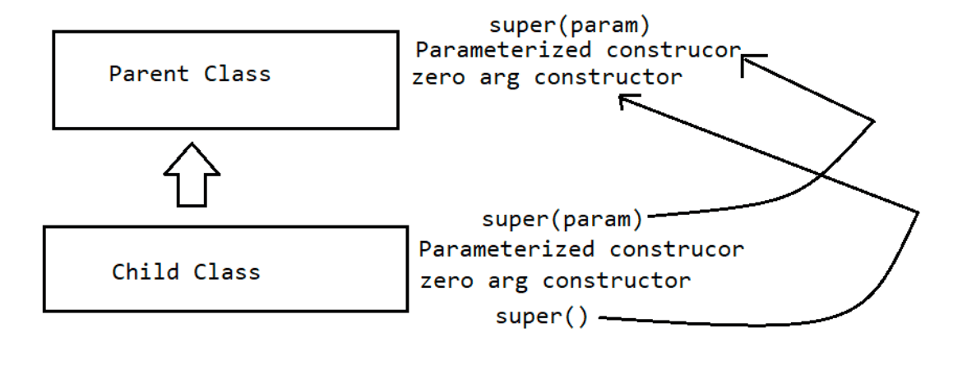
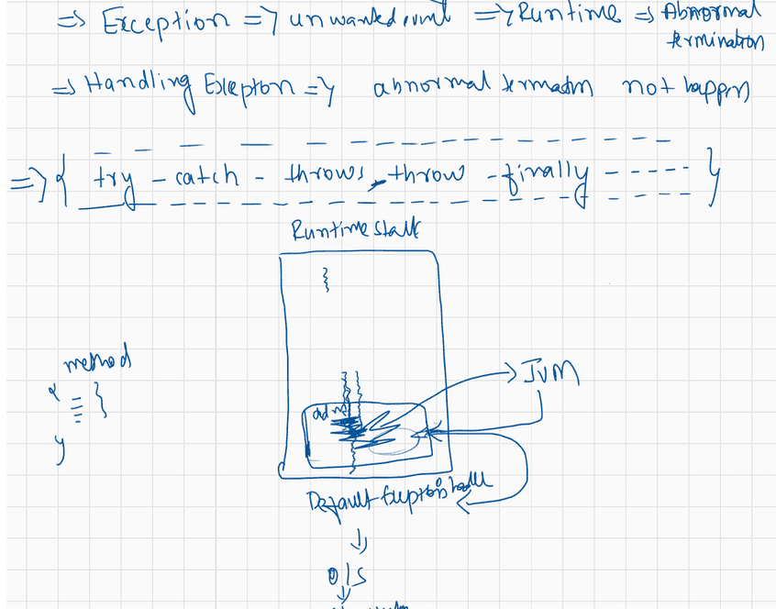
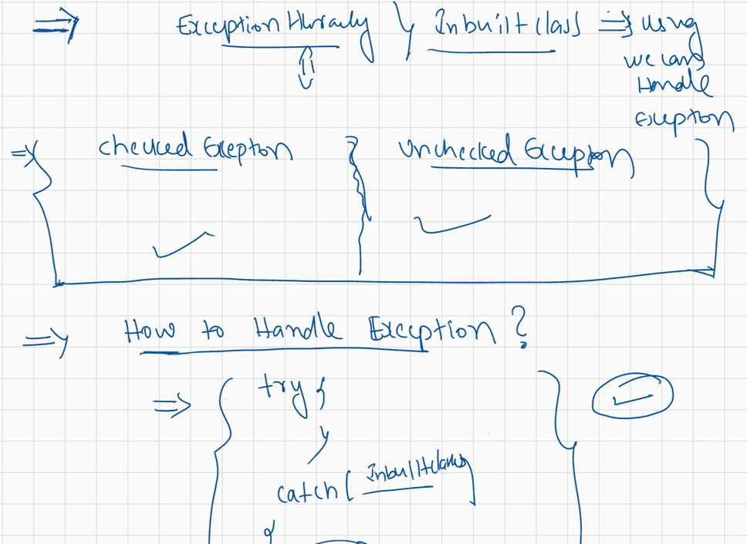

049 Exception Handling part 2
Q.
interface Foo {}
class Alpha implements Foo {}
class Beta extends Alpha {}
class Delta extends Beta {
public static void main( String[] args ) {
Beta x = new Beta();
16. //insert code here 16
}
}
A. Alpha a = x;
B. Foo f = (Delta)x;
C. Foo f = (Alpha)x;
D. Beta b = (Beta)(Alpha)x;
Which code, inserted at line 16, will cause a java.lang.ClassCastException?
Answer: B
Foo(I)
|
|
Alpa(C)
|
|
|
|
|implements
|extends
Beta(C) ======> x -> Foo f = (Delta)x; // invalid becoz the collecting type is of
Foo( which is not related)
|extends
Delta(C)
Q>
Given:
public class Batman {
int squares = 81;
public static void main(String[] args) {
new Batman().go();
}
void go() {
incr(++squares);
System.out.println(squares);
}
void incr(int squares) { squares += 10; }
}
What is the result?
A. 81
B. 82
C. 91
D. 92
E. Compilation fails.
F. An exception is thrown at runtime.
Answer: B
Given:
1. public class Pass {2. public static void main(String [] args) {
3. int x = 5;
4. Pass p = new Pass();
5. p.doStuff(x);
6. System.out.print(" main x = " + x);
7. }
8.
9. void doStuff(int x) {
System.out.print(" doStuff x = " + x++);
10. 11. }
12.}
What is the result?
A. Compilation fails.
B. An exception is thrown at runtime.
C. doStuff x = 6 main x = 6
D. doStuff x = 5 main x = 5
E. doStuff x = 5 main x = 6
F. doStuff x = 6 main x = 5
Answer: D
Q>
Given:
String[] elements = { "for", "tea", "too" };
String first = (elements.length > 0) ? elements[0] : null;
What is the result?
A. Compilation fails.
B. An exception is thrown at runtime.
C. The variable first is set to null.
D. The variable first is set to elements[0].
Answer: D
Note:
int[] data = {10,20,30};
System.out.println(data.length);
String[] names = {"Navin","Haider","Nitin"};
System.out.println(names.length);
System.out.println(names[0].length());
Arrays => To find the length of the array we use length property or variable or
field
String => To find the no of characters present in String we use length().
Q>Given:
10. public class SuperCalc {
11. protected static int multiply(int a, int b) { return a * b;}
12. }
and:
20. public class SubCalc extends SuperCalc{
21. public static int multiply(int a, int b) {
22. int c = super.multiply(a, b); // super => it always refers to
object creation process.
23. return c;
24. }
25. }
and:30. SubCalc sc = new SubCalc ();
31. System.out.println(sc.multiply(3,4));
32. System.out.println(SubCalc.multiply(2,2));
What is the result?
A. 12,4
B. The code runs with no output.
C. An exception is thrown at runtime.
D. Compilation fails because of an error in line 21.
E. Compilation fails because of an error in line 22.
F. Compilation fails because of an error in line 31.
Answer: E
Question
class Foo {
public int a = 3; //instance variable
public void addFive() { a += 5; System.out.print("f "); }
}
class Bar extends Foo {
public int a = 8;//instance variable
public void addFive() { this.a += 5; System.out.print("b " ); }//overrriding
}
Invoked with:
Foo f = new Bar();//loose coupling
f.addFive();//call will be decided by jvm based on runtime object becoz it is
overriding method
System.out.println(f.a);//since a is present in both parent and child compiler only
will bind based on the type
What is the result?
A. b 3
B. b 8
C. b 13
D. f 3
E. f 8
F. f 13
G. Compilation fails.
H. An exception is thrown at runtime.
Answer: A

import java.util.Scanner;

class Alpha
{
void alpha() throws ArithmeticException
{
System.out.println("Connection to Calc app is established");

Scanner scan=new Scanner(System.in);
System.out.println("Enter the first num to divide");
int num1=scan.nextInt();
System.out.println("Enter the 2nd num to divide");
int num2=scan.nextInt();

int res=num1/num2;

System.out.println("The res is "+ res);
System.out.println("Connection is terminated");
}
}

class Beta
{
void beta() throws ArithmeticException
{
Alpha a=new Alpha();
a.alpha();
}
}
public class LaunchException4 {

public static void main(String[] args)
{
try
{
Beta b=new Beta();
b.beta();
}
catch(ArithmeticException e)
{
System.out.println(e.getMessage());
System.out.println("Exception finally handled in main");
}

}

}
//UncheckedException --> Compiler will not force us to handle(It will not be checked during compile time)
//CheckedException--> it will be checked by compiler
public class LaunchException5 {

public static void main(String[] args)throws Exception
{
// TODO Auto-generated method stub
System.out.println("Before sleepn");
Thread.sleep(4000);
System.out.println("after the nap");

}

}

import java.util.Scanner;
//Re-throwing an exception
class Alpha1
{
void alpha() throws ArithmeticException
{
System.out.println("Connection to Calc app is established");
try
{
Scanner scan=new Scanner(System.in);
System.out.println("Enter the first num to divide");
int num1=scan.nextInt();
System.out.println("Enter the 2nd num to divide");
int num2=scan.nextInt();

int res=num1/num2;

System.out.println("The res is "+ res);
}
catch(ArithmeticException e)
{
System.out.println("Exception handled in alpha only");
throw e;
}
finally {
System.out.println("Connection is terminated");
}
}
}

public class LaunchException6 {

public static void main(String[] args)
{
try
{
System.out.println("Main method connection");
Alpha1 a=new Alpha1();
a.alpha();
}
catch(ArithmeticException e)
{
System.out.println("Exception handled in main");
}

}

}

class Demo
{
int disp()
{
try
{
System.out.println("Method started");
return 10;
}
finally {
System.out.println("Method ending");
}
}
}
public class LaunchFinallyReturn {

public static void main(String[] args) {
// TODO Auto-generated method stub
Demo d=new Demo();
d.disp();

}

}
class Demo1
{
void disp()
{
try
{
System.out.println("Method started");
System.exit(0);
}
finally {
System.out.println("Method ending");
}
}
}
public class LaunchFinallySE {

public static void main(String[] args) {
// TODO Auto-generated method stub
Demo1 d=new Demo1();
d.disp();
}

}
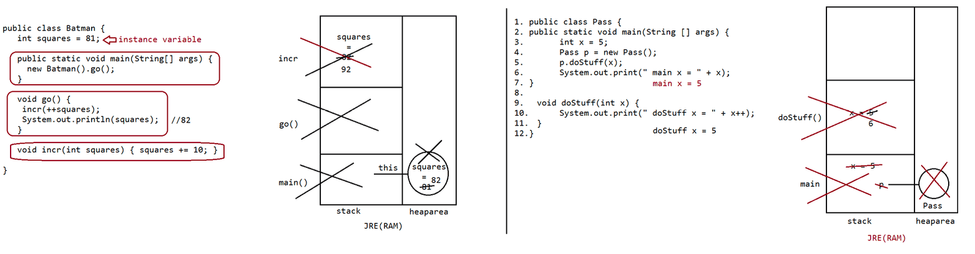
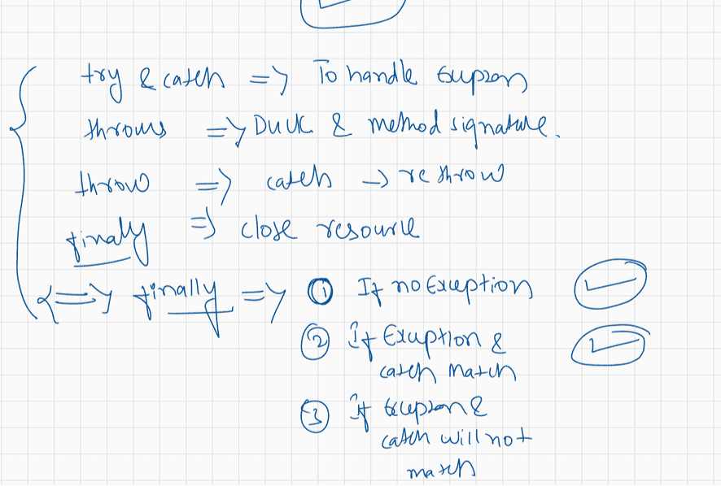
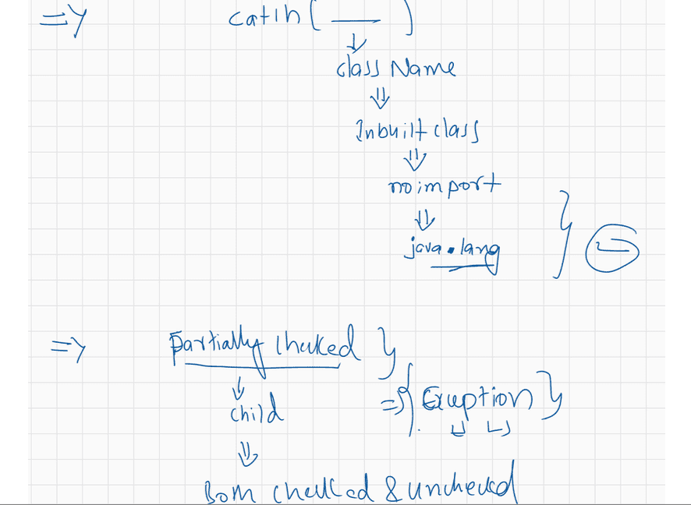
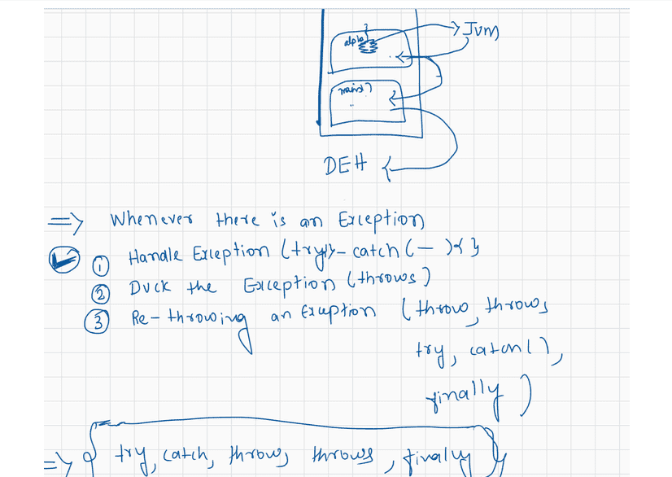

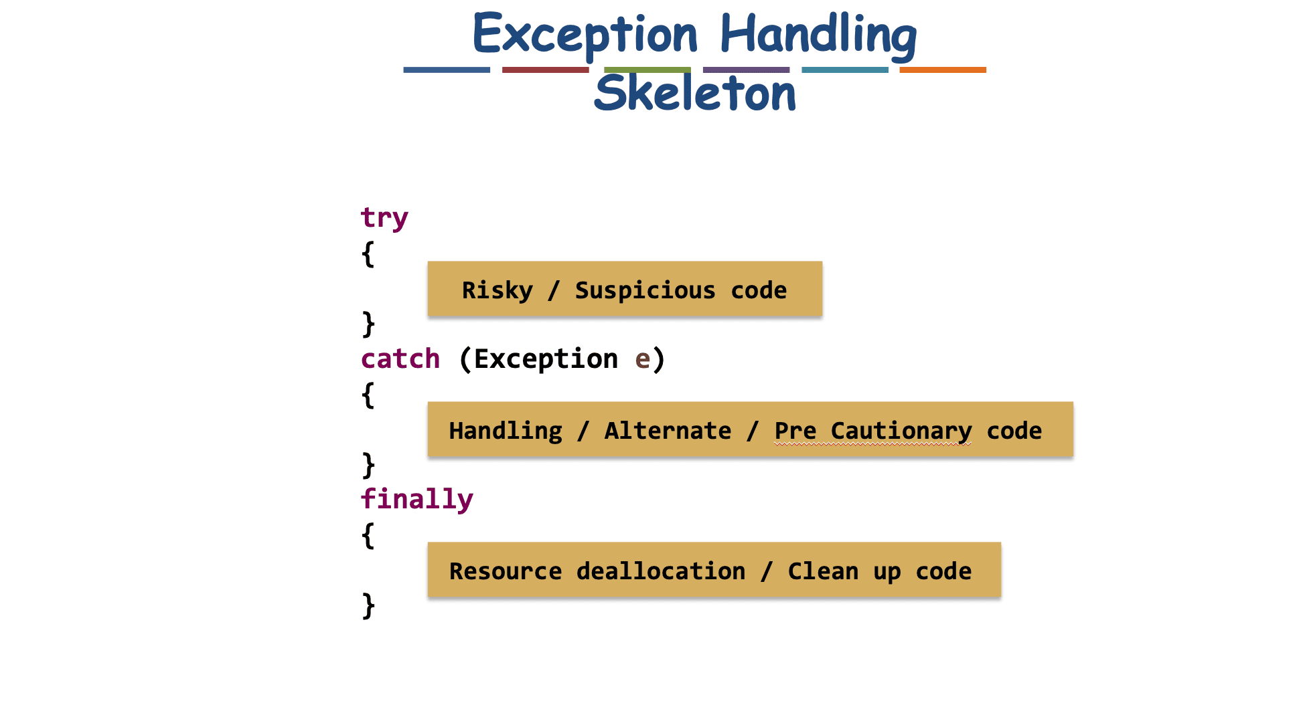
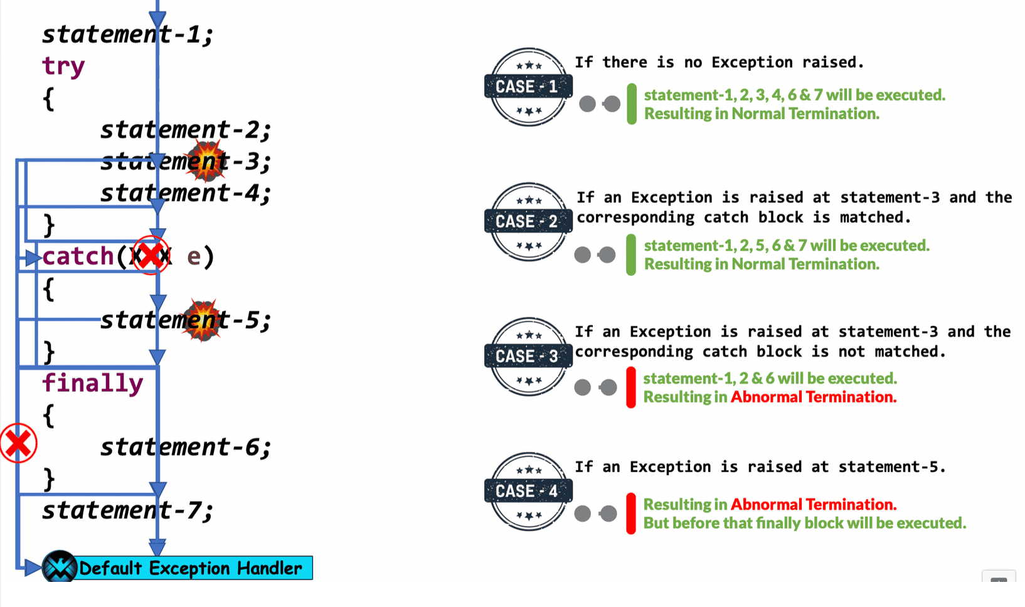
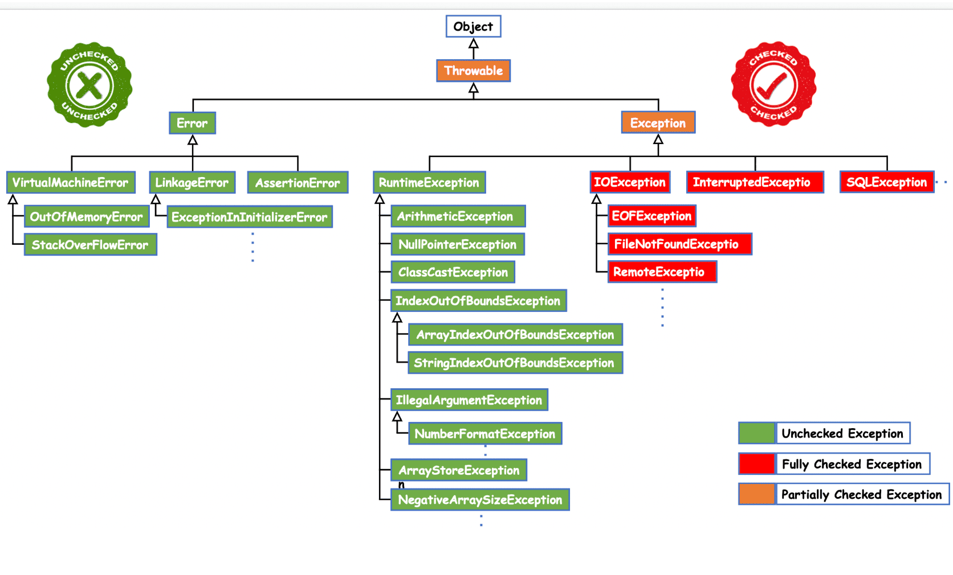
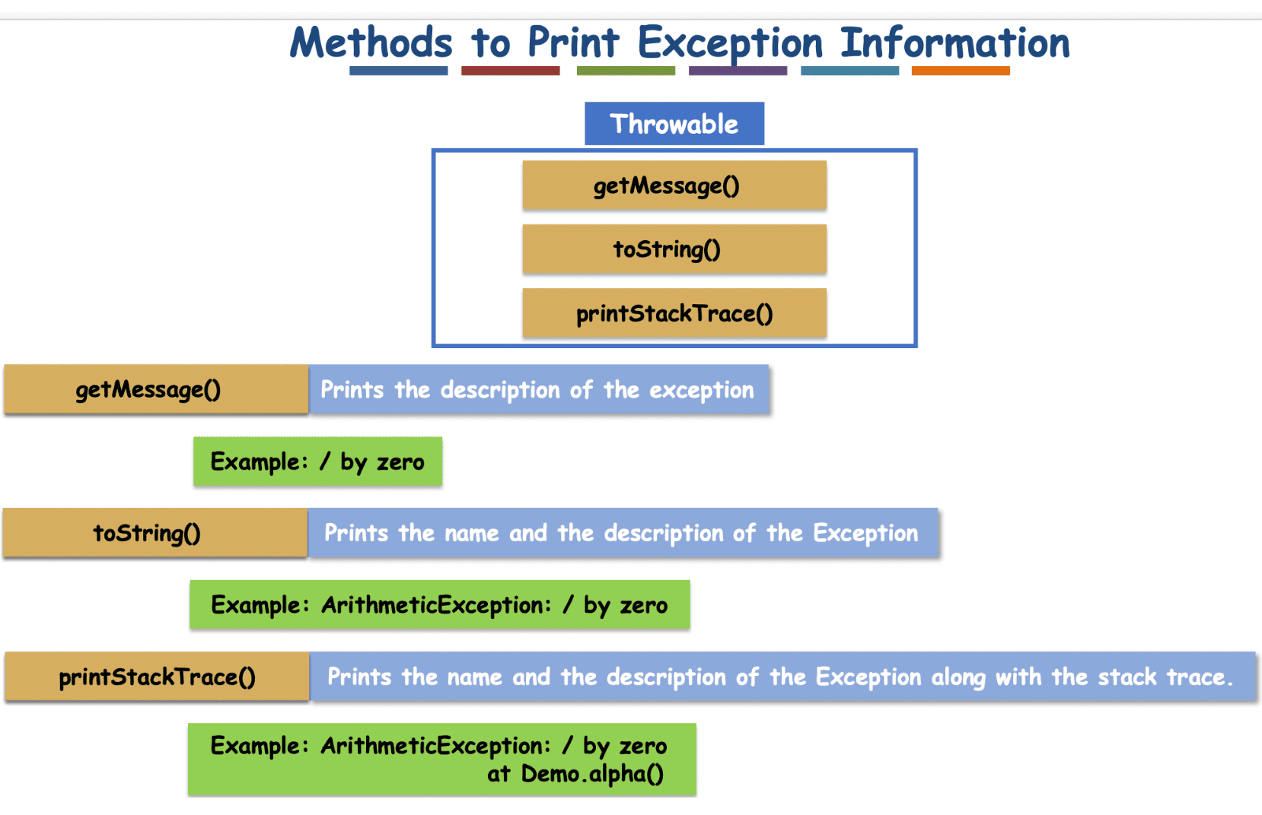
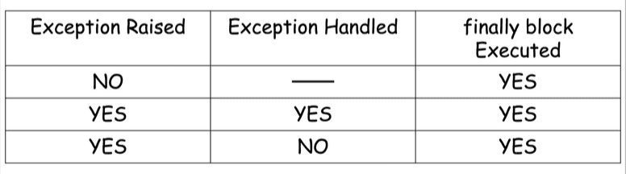
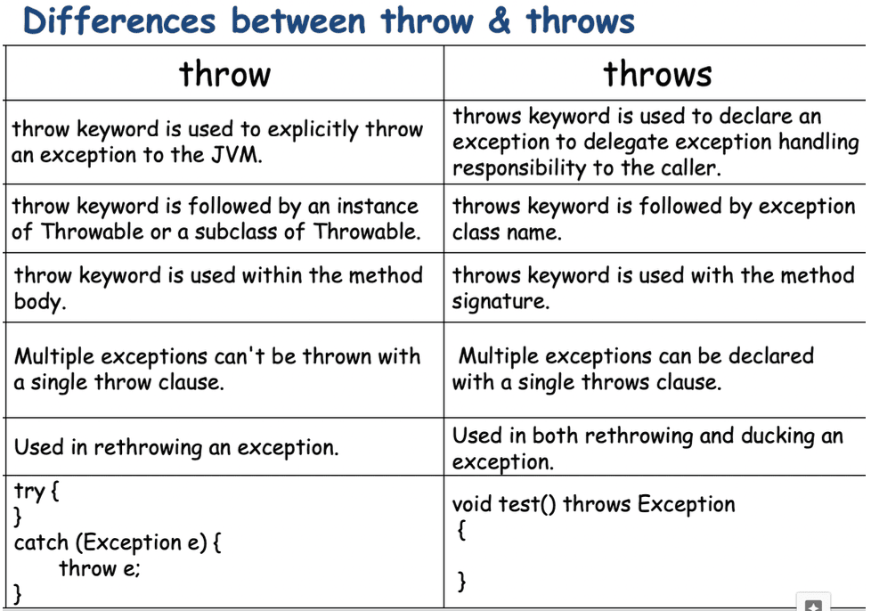

050 Exception handling part 03
Q>
class Thingy { Meter m = new Meter(); }
class Component { void go() { System.out.print("c"); } }
class Meter extends Component { void go() { System.out.print("m"); } }
class DeluxeThingy extends Thingy {
//meter object would come and meter would extend component so navigation is
possible
public static void main(String[] args) {
DeluxeThingy dt = new DeluxeThingy();
dt.m.go();
Thingy t = new DeluxeThingy();
t.m.go();
}
}
Which two are true? (Choose two.)
A. The output is mm.
B. The output is mc.
C. Component is-a Meter.
D. Component has-a Meter.
E. DeluxeThingy is-a Component.
F. DeluxeThingy has-a Component.
relationship b/w 2 classes as inheritance => IS-A relation
relationship b/w 2 classes which are used for navigation => HAS-A relationship
Answer: A F
Q>
public class Test{
public static void main(String[] args){
boolean a =new Boolean(Boolean.valueOf(args[0]));//new Boolean(false)
System.out.println(a);//false
boolean b =new Boolean(args[1]);//new Boolean("null")
System.out.println(b);//false
}
}
And the commands are
javac Test.java
java Test 1 null
commandline arguments
====================
args[0] = "1"
args[1] = "null"
What is the result?
A. 1 null
B. true false
C. false false
D. true true
E. Class cast Exception is thrown at the runtime
Answer: C
Q>
public class Test {
public static void doSum(int x, int y){System.out.println("int sum is:: "+(x+y));
}
public static void doSum(Integer x, Integer y){
System.out.println("Integer sum is:: "+(x+y));
}
public static void doSum(double x, double y){
System.out.println("double sum is:: "+(x+y));
}
public static void doSum(float x, float y){
System.out.println("float sum is:: "+(x+y));
}
public static void main(String[] args) {
doSum(10,20);
doSum(10.0,20.0);
}
}
What is the result?
A. int sum is :: 30
float sum is :: 30.0
B. int sum is :: 30
double sum is :: 30.0
C. Integer sum is :: 30
double sum is :: 30.0
D. Integer sum is:: 30
float sum is :: 30.0
Answer: B
Q>
Given:
1. public class BuildStuff {
2. public static void main(String[] args) {
3. Boolean test = new Boolean(true);//test = true
4. Integer x = 343;
5. Integer y = new BuildStuff().go(test, x);// true,343
6. System.out.println(y);//49
7. }
8. int go(Boolean b, int i) {
9. if(b) return (i/7);// return 343/7 => 49
10. return (i/49);
11. }
12.}
What is the result?
A. 7
B. 49
C. 343
D. Compilation fails.
E. An exception is thrown at runtime.
Answer: B
Q>
class Vehicle{
int x;
Vehicle(){this(10);
}
Vehicle(int x){
this.x = x;
}
}
class Car extends Vehicle{
int y;
Car(){
super(); // line-n1
this(20);//line-n2
}
Car(int y){
this.y= y;
}
public String toString(){
return super.x + " " + this.y;
}
}
public class Test {
public static void main(String[] args) {
Vehicle y= new Car();
System.out.println(y);
}
}
Predict the answer
A. 10:20
B. 0:20
C. Compilation fails at line n1
D. Compilation fails at line n2
Answer: D
Q>
public static void main(String[] args) {
Integer i = new Integer(1) + new Integer(2);//line-12
switch(i) {//line-13
case 3: System.out.println("three"); break;
default: System.out.println("other"); break;//line-15
}
}
What is the result?
A. three
B. other
C. An exception is thrown at runtime.
D. Compilation fails because of an error on line 12.
E. Compilation fails because of an error on line 13.
F. Compilation fails because of an error on line 15.
Answer: A
Q>
Given:
public class Foo {
static int[] a;
static { a[0]=2; }
public static void main( String[] args ) {}
}
Which exception or error will be thrown when a programmer attempts to run thiscode?
A. java.lang.StackOverflowError
B. java.lang.IllegalStateException
C. java.lang.ExceptionInInitializerError
D. java.lang.ArrayIndexOutOfBoundsException
static{
//if some excpetion occurs during initialization then it is called as
"ExceptionInInitalizerError"
}
Q>
Given:
10. interface Jumper { public void jump(); }
...
20. class Animal {}
...
30. class Dog extends Animal {//Dog IS-A Animal , Dog Has-A tail
31. Tail tail;
32. }
...
40. class Beagle extends Dog implements Jumper{//Beagle is a Dog,Beagle is a
Animal,Beagle has-a tail, Beagle is-A jumper
41. public void jump() {}
42. }
...
50. class Cat implements Jumper{//Cat is-a jumper
51. public void jump() {}
52. }
Which three are true? (Choose three.)
A. Cat is-a Animal
B. Cat is-a Jumper
C. Dog is-a Animal
D. Dog is-a Jumper
E. Cat has-a Animal
F. Beagle has-a Tail
G. Beagle has-a Jumper
Answer: BCF
QUESTION
Given:
1. class X {
2. X() { System.out.print(1); }
3. X(int x) {
4. this(); System.out.print(2);
5. }
6. }
7. public class Y extends X {
8. Y() { super(6); System.out.print(3); }
9. Y(int y) {
10. this(); System.out.println(4);
11. }
12. public static void main(String[] a) { new Y(5); }
13.}
What is the result?
A. 13
B. 134
C. 1234D. 2134
E. 2143
F. 4321
Answer: C(1234)
import java.util.Scanner;

class InvalidCustomerException extends Exception
{
public InvalidCustomerException(String msg)
{
super(msg);
}

}
class Atm
{
int userid=1212;
int password=1111;
int pw;
int uid;
public void input()
{
Scanner scan=new Scanner(System.in);

System.out.println("Kindly enter the user id");
uid=scan.nextInt();

System.out.println("Kindly enter the pasword");
pw=scan.nextInt();
}
public void verify() throws InvalidCustomerException
{
if((userid== uid) && (password == pw))
{
System.out.println("Take your cash");
}
else
{
InvalidCustomerException ice=new InvalidCustomerException("Are you sure? try again bcz wrong input");
//System.out.println(ice);
System.out.println(ice.getMessage());
throw ice;
}
}
}

class Bank
{
public void initiate()
{
Atm a=new Atm();
try
{
a.input();
a.verify();

}
catch (InvalidCustomerException e1)
{
try
{
a.input();
a.verify();

}
catch (InvalidCustomerException e2)
{
try
{
a.input();
a.verify();

}
catch (InvalidCustomerException e3)
{

System.out.println("Oh Choor dude we caught you card is blocked!!");
System.exit(0);
}

}

}
}
}
public class LaunchCE {

public static void main(String[] args) {

Bank b=new Bank();
b.initiate();

}

}

//UncheckedException --> Compiler will not force us to handle(It will not be checked during compile time)
//CheckedException--> it will be checked by compiler
public class LaunchException5 {

public static void main(String[] args)throws Exception
{
// TODO Auto-generated method stub
System.out.println("Before sleepn");
Thread.sleep(4000);
System.out.println("after the nap");

}

}

import java.util.Scanner;
//Re-throwing an exception
class Alpha1
{
void alpha() throws ArithmeticException
{
System.out.println("Connection to Calc app is established");
try
{
Scanner scan=new Scanner(System.in);
System.out.println("Enter the first num to divide");
int num1=scan.nextInt();
System.out.println("Enter the 2nd num to divide");
int num2=scan.nextInt();

int res=num1/num2;

System.out.println("The res is "+ res);
}
catch(ArithmeticException e)
{
System.out.println("Exception handled in alpha only");
throw e;
}
finally {
System.out.println("Connection is terminated");
}
}
}

public class LaunchException6 {

public static void main(String[] args)
{
try
{
System.out.println("Main method connection");
Alpha1 a=new Alpha1();
a.alpha();
}
catch(ArithmeticException e)
{
System.out.println("Exception handled in main");
}

}

}

import java.util.Scanner;
class UnderAgeException extends Exception
{
public UnderAgeException(String message)
{
super(message);
}
}
class OverAgeException extends Exception
{
public OverAgeException(String message)
{
super(message);
}

}

class Applicant
{
int age;
public void input()
{
Scanner scan=new Scanner(System.in);
System.out.println("Please enter your age");
age=scan.nextInt();
}
//void verify() throws Exception
void verify() throws UnderAgeException,OverAgeException
{
if(age <18)
{
UnderAgeException uae=new UnderAgeException("Ohh dude? calm down your time will come");
System.out.println(uae.getMessage());
throw uae;
}
else if(age > 60)
{
OverAgeException oae=new OverAgeException("your time is near calm down and pray");
System.out.println(oae.getMessage());
throw oae;
}

else
{
System.out.println("You're eligible");
}
}
}

class Rto
{
public void initiate()
{
Applicant a=new Applicant();
try
{
a.input();
a.verify();
}
catch(UnderAgeException| OverAgeException e)
{
try
{
a.input();
a.verify();
}
catch(UnderAgeException |OverAgeException e1)
{
System.out.println("Don't ever try again read rules");
System.exit(0);
}

}
// try
// {
// a.input();
// a.verify();
// }
// catch(OverAgeException e)
// {
// try
// {
// a.input();
// a.verify();
// }
// catch(OverAgeException e1)
// {
// System.out.println("Don't ever try again read rules");
// System.exit(0);
// }
}
}

public class LaunchRto {

public static void main(String[] args) {
Rto r=new Rto();
r.initiate();

}

}

